

**Faculty of engineering - Shoubra**

**Benha University**

**Research Article / Research Project / Literature Review**

in fulfillment of the requirements of

|  |  |
| --- | --- |
| **Department** | **Engineering Mathematics and Physics** |
| **Division** | **-----------------** |
| **Academic Year** | **2019-2020 Preparatory** |
| **Course name** | **Computer** |
| **Course code** | **ECE001** |

**Title: -**

**Build a website on Programming Languages**

By:

|  |  |  |  |
| --- | --- | --- | --- |
|  | Name | Edu mail | B.N |
| 1 | محمود حسن محمود احمد | Mahmoud195937@feng.bu.edu.eg | 839 |

**Website Link:** <https://mahmoud-hassan-ghania.github.io/ece001/>

**Approved by:**

|  |  |
| --- | --- |
| Examiners committee | Signature |
| Dr.Ahmed Bayoumi |  |
| Dr.Shady Elmashad |  |
| Dr.AbdelhamidAttaby |  |

**Introduction**

The programming language, is a set of commands, written according to rules determined by the programming language, and then these commands go through several stages until they are executed on the computer. There is a different types of Programming language and each one has its field some is for web page and some is for making programs and some for making mobile application. In this website we will discuss this.

**Types of Programming Languages:-**

1. **Low level programming languages:**
   1. Machine code
   2. Assembly Language
   3. TMG language
2. **Some of High level programming languages:**
   1. C++
   2. Java
   3. C#
   4. Pascal

**Types of Programming Languages:-**

**1) Low level programming languages**

Low-level programming language is a programming language that provides little or no abstraction from a computer's instruction set architecture commands or functions in the language map closely to processor instructions.

**2) High level programming languages**

High-level programming language is a programming language with strong abstraction from the details of the computer. In contrast to low level programming languages. It may use natural language elements or it sometimes be easier than the natural language. His process of developing a program simpler and more understandable than when using a lower level language.

**Screenshots of my website**

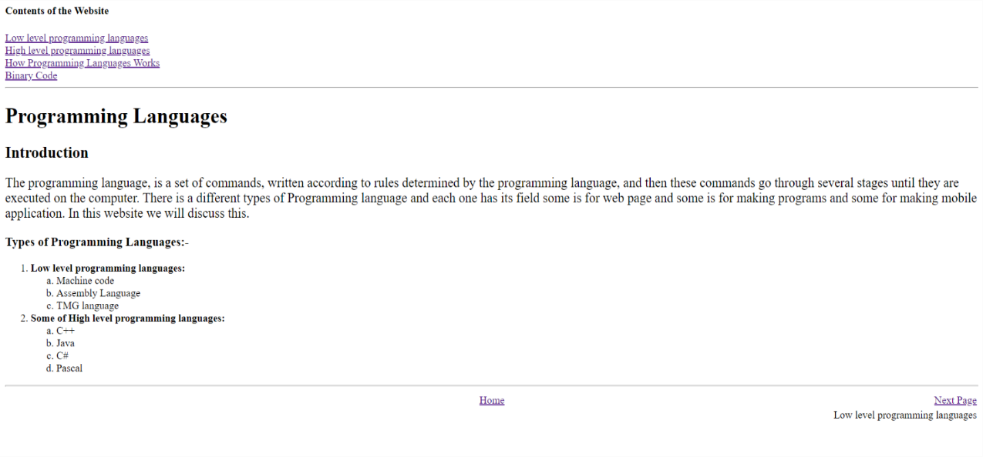Main page

Page 1

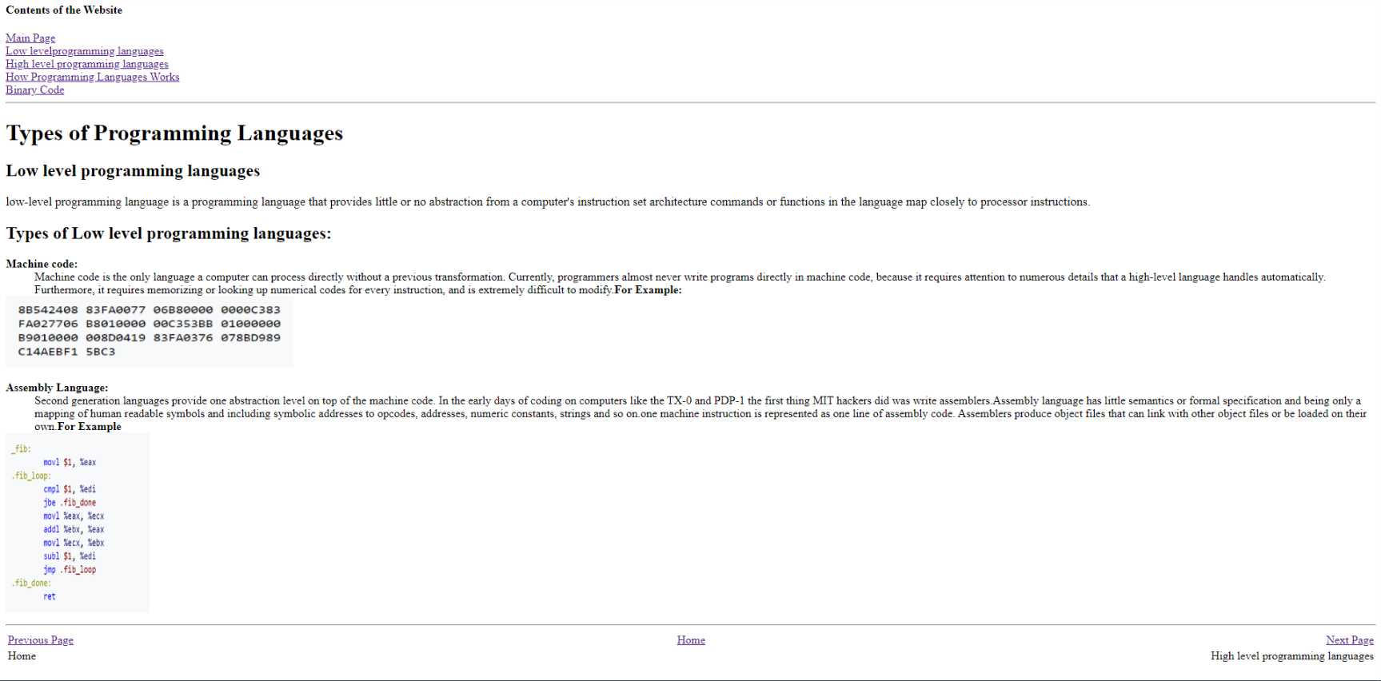

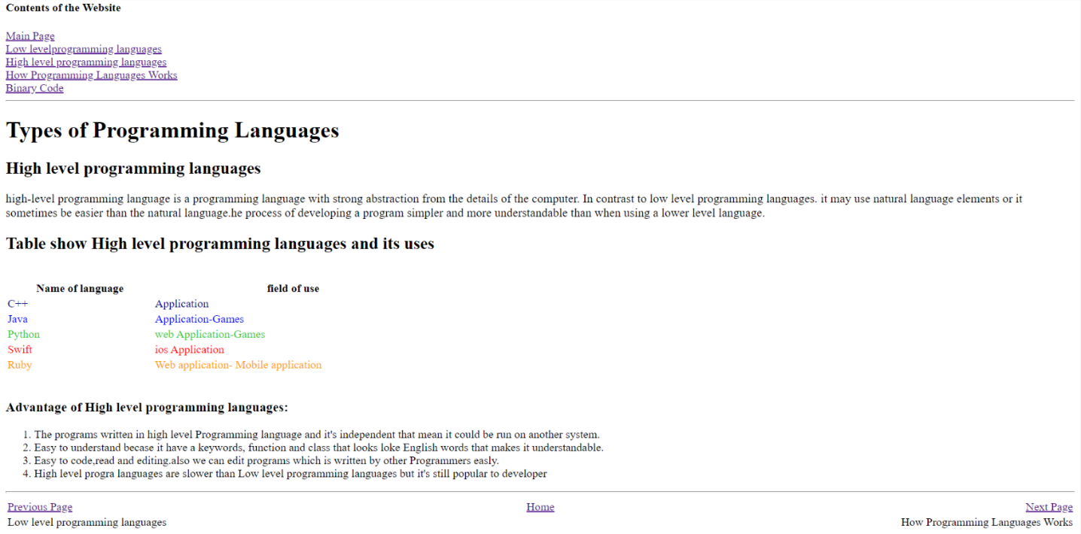 Page 2

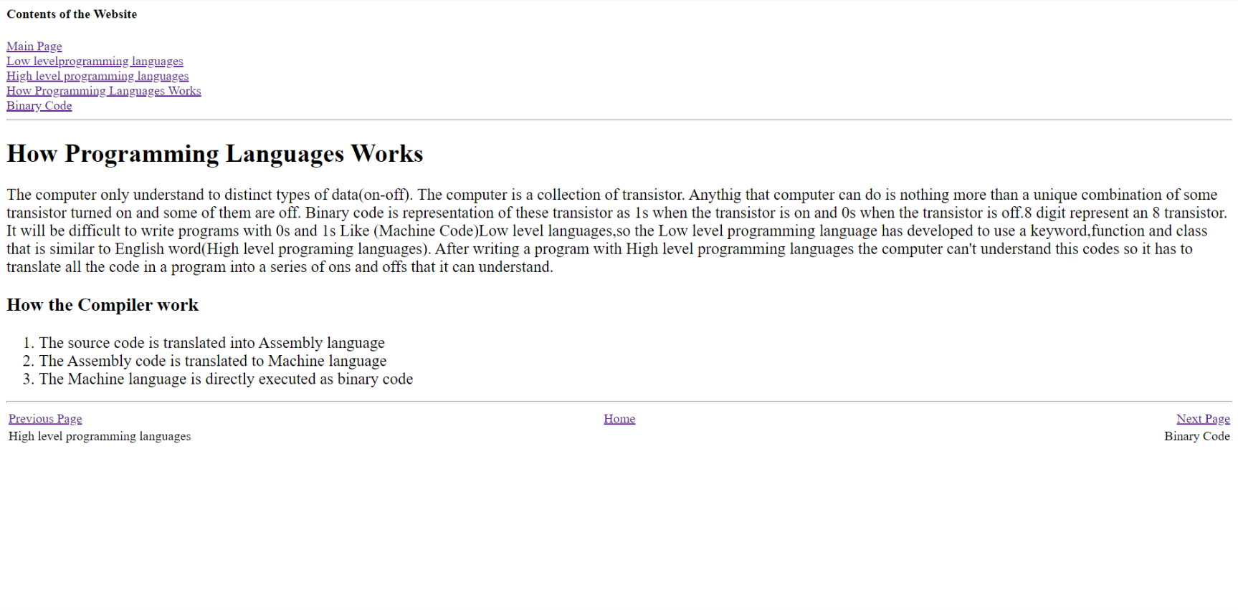Page 3

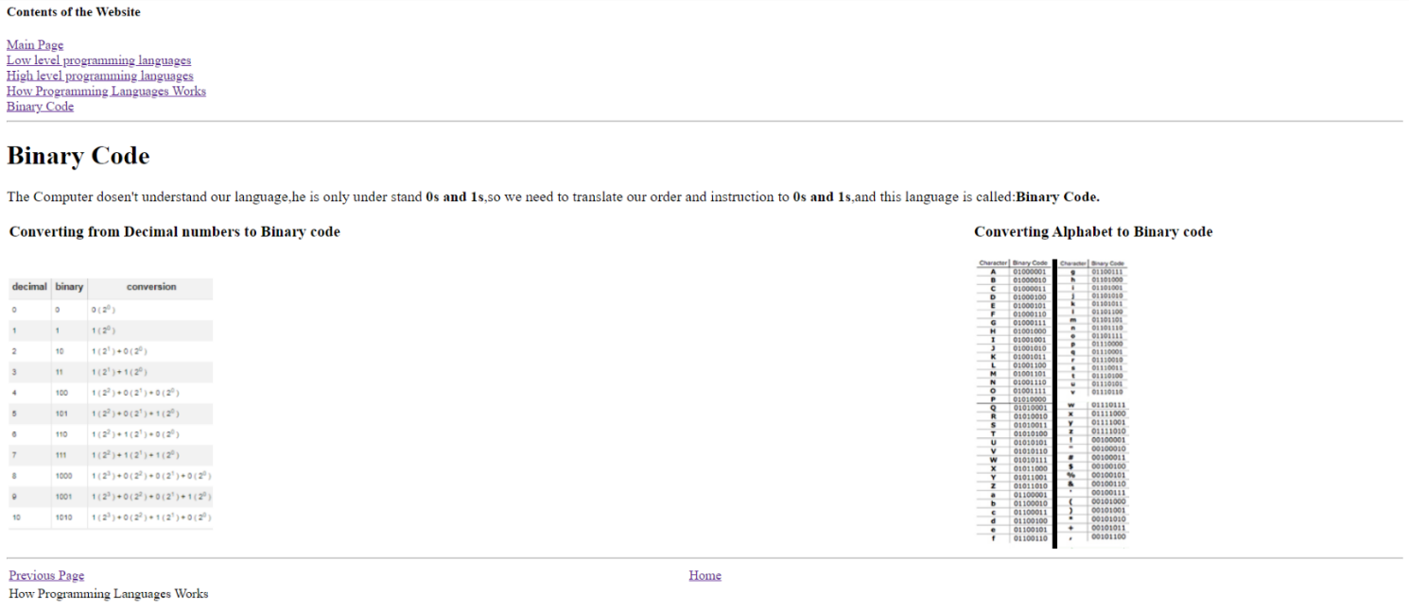Page 4

**Screenshots of the source code**

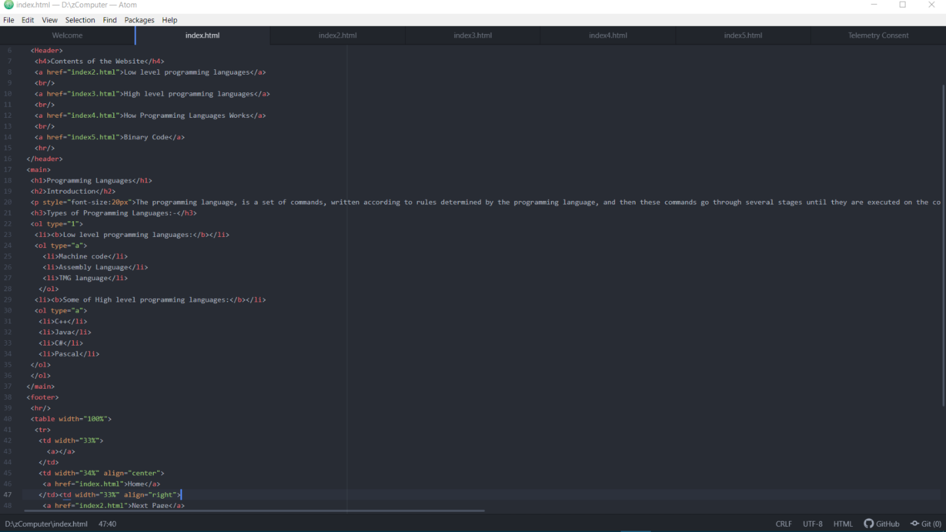Main page

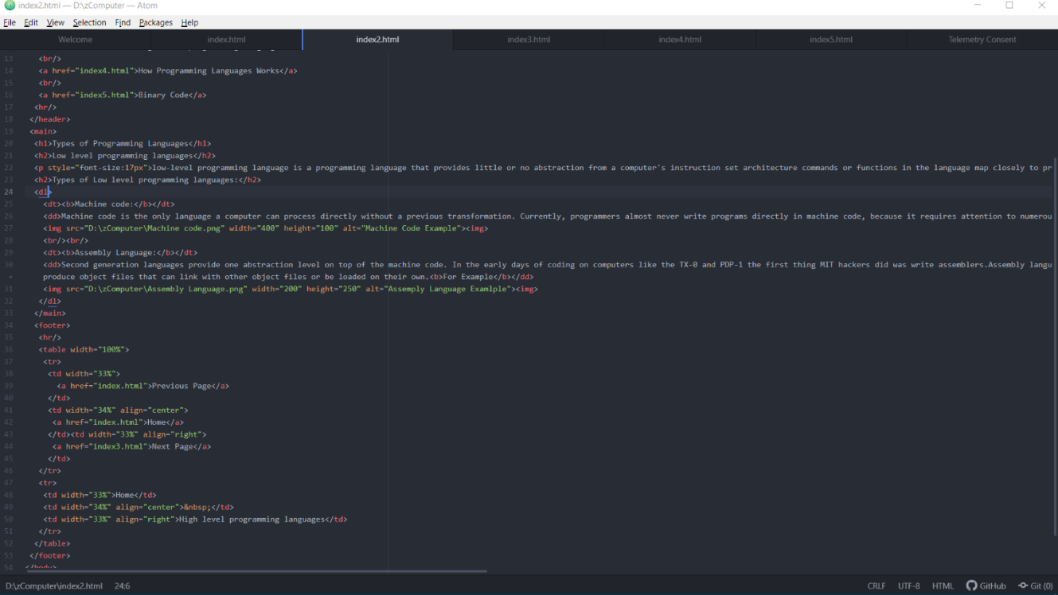Page 1

Page 2

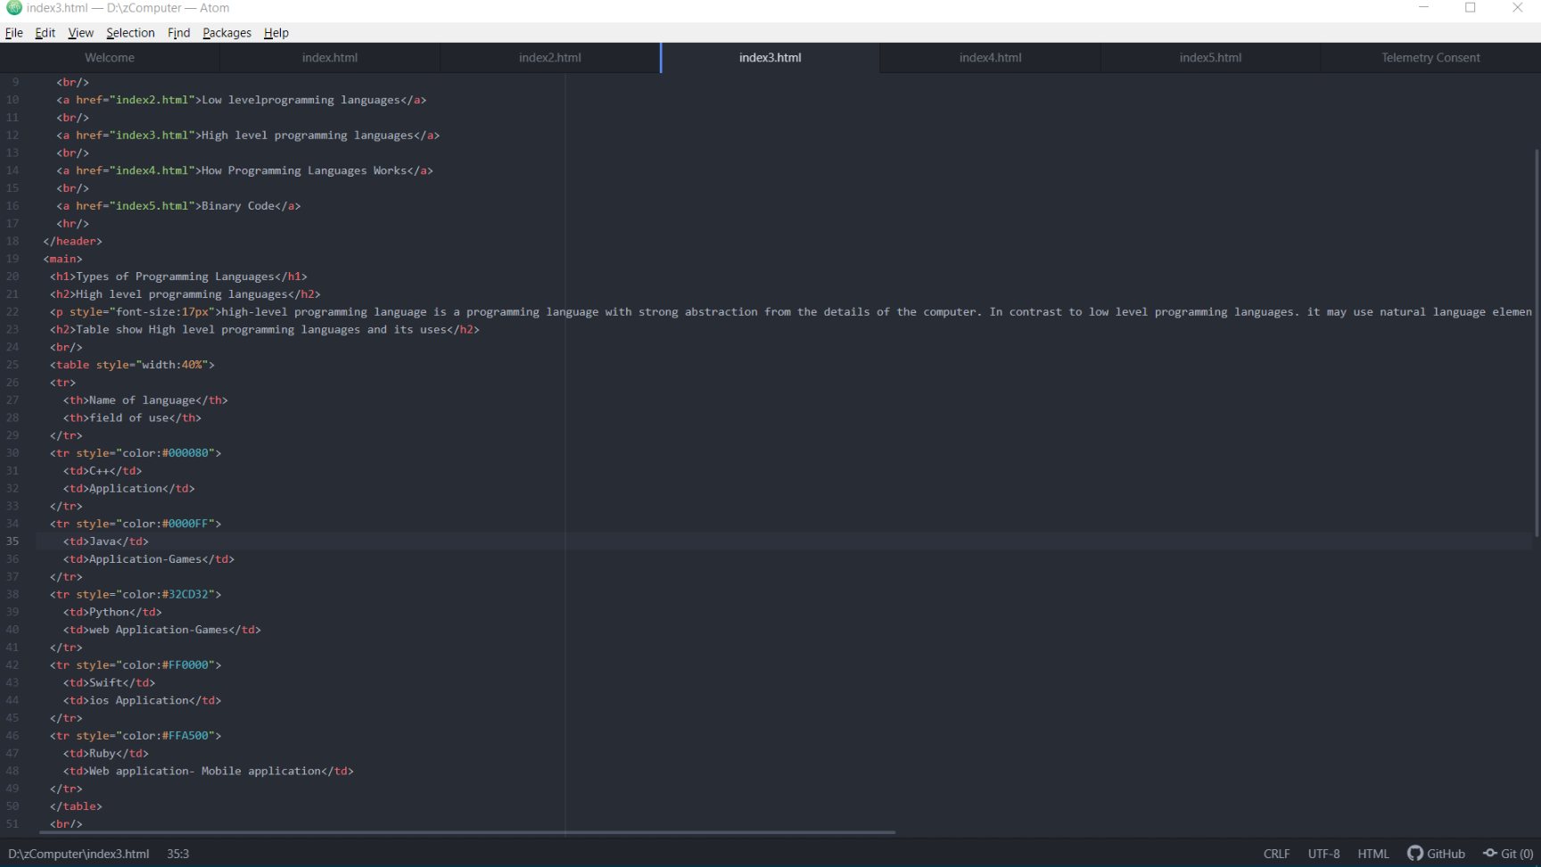

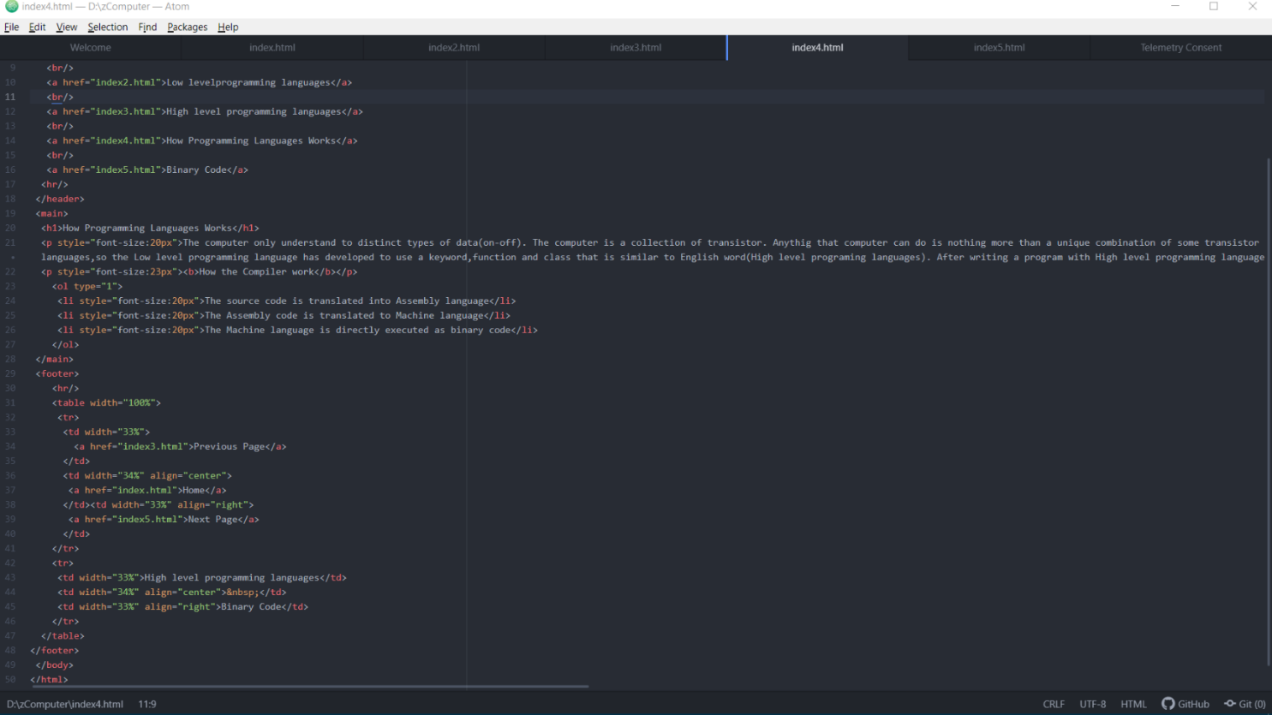Page 3

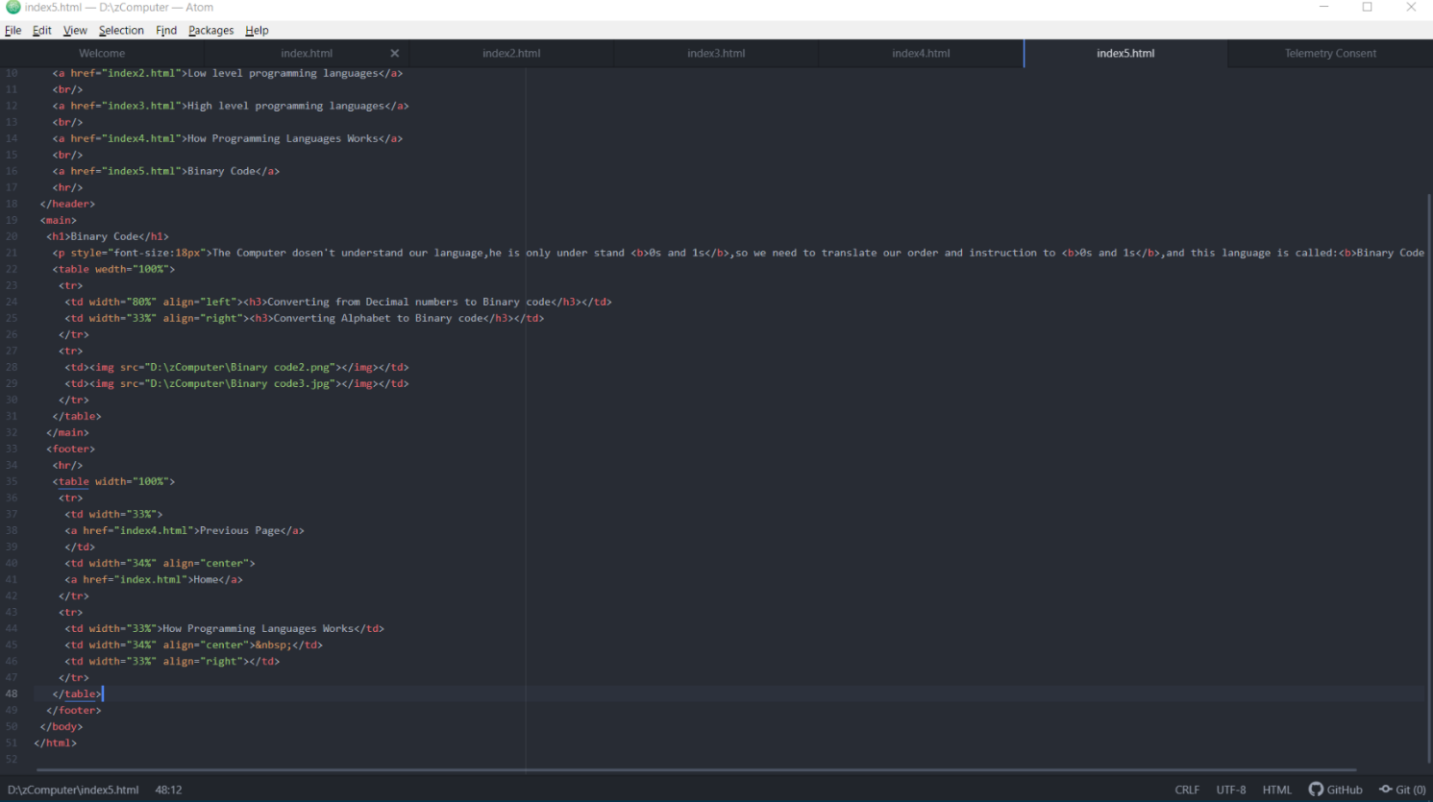Page 4